**BIT302**

**Software Engineering**



**ASSIGNMENT 1**

**Project Proposal**

**“Web-based Information System for MicroHousing System in Kuala Lumpur”**

**Team Leader:**

**Luh Wulandari Maharani**

**E1700873 / 170030401**

**luhwulandari@gmail.com**

**Member:**

**Rivaldo Bagus Soepardhy**

**E1700882 / 170030400**

**aldobagus@hotmail.co.id**

Table of Content

Introduction 2

Project Background 3

Project Aims 3

Project Objectives 3

Project Scope 4

Project Schedule 6

Work Breakdown Structure 7

Milestones 8

Gantt Chart 8

Development Platform 9

Demonstration Platform 10

Risk Management Plan 11

References 12

Introduction

For almost a decade, Internet has been rapidly developed and it pushes for more development of advanced technology, helping individuals to do work better. Businesses, companies, industries is trying to take advantage of technology development to enhance and improve their operations on daily basis. This has been done by industrials in order to provide better product & services to customer and attract for more benefits.

Most of businesses nowadays will rely on a web-based or web application information system. Information systems are combinations of hardware, software, and telecommunications networks that people build and use to collect, create, and distribute useful data, typically in organizational settings (Valacich & Schneider, 2010). A web application (or "web app" for short) is any computer program that performs a specific function by using a web browser as its client (Nations, 2019).

Project Background

With nowadays-human population that is greatly (and rapidly) increases, house and land is component that start to become a problem. This is happened due to inequality of economy (common sense) between people. With that said, certain people will have to live in a temporary living place (Apartment, hotels, etc.), while others have their permanent house. The problem that, as population increases, it is starting to be very hard to get a land and build a house, or even rent a temporary living place. Some says because old people have too much house, that makes young people hard to get one (Anderssen, 2018). Some says because either of minimum wages they have that cannot even pay a rent (Anderssen, 2018), (Regan, 2018), or even because there are no more place for rent. Even youths who are looking for boarding house couldn’t even afford to pay rent because of low wages (or inadequate economy), or also because there’s almost no place that is available to rent. (Carney, 2018), (Babulal & Athirah, 2019).

This problems turns out also hitting youths in Malaysia. Therefore, Kuala Lumpur City Hall has proposed a scheme to help youths to rent accommodation or boarding houses at affordable prices (Babulal & Athirah, 2019). With this, we want to take the advantage of web-based information system, hoping to help government to accommodate youths in more proper and better way while we can also help youths to get the accommodation in a more efficient, easier, and faster ways.

To build this system, we have to know the features of the boarding house, the cost and how many it can accommodate. We also need personal information (Name, email, rent duration, etc.) of applicants that will register themselves for the boarding house. With this system, the housing officer will have easier & efficient way to maintain & monitor applicants that are living in the micro houses, applicants that already pay rents or not yet, etc.

We will put the data of personal information & rent bill in a database handled by Housing Officer. Housing Officer will be given password to access the system to add, delete and update the data. Each applicant will get a user ID and password to see their personal information, rent bill, duration, contact details of housing officers, etc. The desired outcome will be a web – based information system that allows applicants to see their information in real time.

Project Aims

* To change the traditional way of transaction & interaction between government and people about micro housing.
* To provide easier way for government to manage house rent for youths with low wages.
* To provide efficient and convenient way of youths in search of boarding house with affordable price.

Project Objectives

1. Conducting a research about type of micro house that will be rented
2. Determining how many people can be accommodated into a micro house
3. Listing features that will be available for each houses
4. Select tools and programming language that are most suitable to develop the information system
5. Produce documents that are necessary for the completion of this project
6. Decide the design of UI.
7. Creating database and input all the data that are needed
8. Integrating database and web design to produce a complete application

Project Scope

|  |
| --- |
| * **Project Title:** Web-based Information System for Micro Housing System in Kuala Lumpur * **Date:** February 7th 2020 * **Prepared by:** Luh Wulandari Maharani, Team Leader, luhwulandari@gmail.com |
| **Project Summary and Justification:**  This information system is made to help government in terms of the development of DBKL Micro Housing Scheme, while also helping youths to find a more affordable price for boarding house. Through the system, we are integrating database system and website design. The system will be managed by Housing Officer to add, delete and update data. In the end, Housing Officer can maintain & monitor activities & accommodation (availability, management etc.), while youths (college or high school students) can live in a proper boarding house with affordable price. Youths can also monitor their rent bill during their stay, checking their duration, personal information, and contact details of regarding parties. |
| **Product Characteristics and Requirement:**   1. Research on government for DBKL Micro Housing Scheme to know specific requirements, models, types, features, etc. 2. Research on common property that applied web-based information system for their business. 3. Providing content that suitable to solve problems or making things easier and efficient. The web-based information system should be informative and helpful by showing all data that are applicants and Housing Officer need to see. 4. The web application will be tested with different browsers to make sure it is accessible and does not have any display problem. 5. The entire link will be tested, to see if the link work properly or not. |
| **Summary of Project Deliverables**  **Project management-related deliverables:** Project aims, project objectives, scope statement, WBS, schedule, requirements specification document, design and testing documentation, working web-based information system, final project presentation, and other documents required to manage the project.  **Product-related deliverables:**   1. Web-based information system that can be accessed by any registered applicants. 2. The content of the web allows applicants to know what type of micro housing they are going to have, features, capacity, duration, availability of the micro housing. 3. Ability to manage communication and coordination between Housing Officer and applicants regarding accommodation & availability of boarding house. |
| **Project Success Criteria:** Our goal is to complete this project within three months. The project will be considered successful if it meets the entire product characteristic and requirement listed above, and does not misaligned with the project scope. The project team will succeed if they can follow team contract and stay on track of WBS and Gantt Chart that has been created. |

Project Schedule

|  |  |  |  |  |
| --- | --- | --- | --- | --- |
| **Schedule** | **Start Date** | **End Date** | **Estimate Days** | **Responsible** |
| **Initiating** | | | | |
| Identifying Topic | Fri,7/2/2020 | Fri,7/2/2020 | 1 day | All |
| Conducting Research | Mon, 10/2/2020 | Wed,12/2/2020 | 3 days | All |
| Identifying Project Aims and Background | Thu,13/2/2020 | Fri,14/2/2020 | 2 days | All |
| Identifying Non Functional and Functional Requirements | Mon,17/2/2020 | Wed,19/2/2020 | 3 days | All |
| Complete Initiating Task | Wed,19/2/2020 | Wed,19/2/2020 | 0 day | All |
| **Planning** | | | | |
| Determining Project Scope | Fri,7/2/2020 | Fri,7/2/2020 | 1 day |  |
| Determining WBS | Fri,7/2/2020 | Fri,7/2/2020 | 1 day | Wulan |
| Project Schedule | Fri,7/2/2020 | Fri,7/2/2020 | 1 day | Wulan |
| Baseline Gantt Chart | Fri,7/2/2020 | Fri,7/2/2020 | 1 day | Wulan |
| Development and Demonstration Platform | Mon, 10/2/2020 | Wed,12/2/2020 | 3 days |  |
| Risk Management Plan | Thu,13/2/2020 | Fri,14/2/2020 | 2 days | Aldo |
| Use Case Diagram and Class Diagram | Mon,17/2/2020 | Wed,19/2/2020 | 3 days | Wulan |
| Expanded Use Cases | Thu,20/2/2020 | Fri,21/2/2020 | 2 days | Wulan |
| Analysis Class Diagram | Mon,24/2/2020 | Tue,25/2/2020 | 2 days |  |
| **Executing** | | | | |
| Web Page Basic Design | Thu,27/2/2020 | Wed,25/3/2020 | - | All |
| Prototype Developing Process | Thu,27/2/2020 | Wed,25/3/2020 | - | All |
| System Finishing | Fri,24/4/2020 | Fri,24/4/2020 | - | All |
| **Monitoring and Controlling** | | | | |
| Update the Gantt Chart | Thu,27/2/2020 | Fri,24/4/2020 | - | Wulan |
| Testing the Prototype | Thu,26/3/2020 | Fri,27/3/2020 | - |  |
| Testing the Complete System | Fri,28/2/2020 | Fri,28/2/2020 | - |  |
| **Closing** | | | | |
| Final Report | Tue,3/3/2020 | Tue,3/3/2020 | 0 day |  |

Work Breakdown Structure

1. Initiating Tasks
2. Identifying Topic
3. Conducting Research
4. Identifying Project Aims and Background
5. Identifying Non Functional and Functional Requirements
6. Complete Initiating Task
7. Planning Tasks
8. Determining Project Scope
9. Determining WBS
10. Project Schedule
11. Baseline Gantt Chart
12. Development and Demonstration Platform
13. Risk Management Plan
14. Use Case Diagram and Class Diagram
15. Expanded Use Cases
16. Analysis Class Diagram
17. Executing Tasks
18. Web Page Basic Design
19. Prototype Developing Process
20. System Finishing
21. Monitoring and Controlling Tasks
22. Update the Gantt Chart
23. Testing the Prototype
24. Testing the Complete System
25. Closing
26. Final Report

Milestones

* Complete Initiating Task
* Testing the Prototype
* Testing the Complete System
* Final Report

Gantt Chart

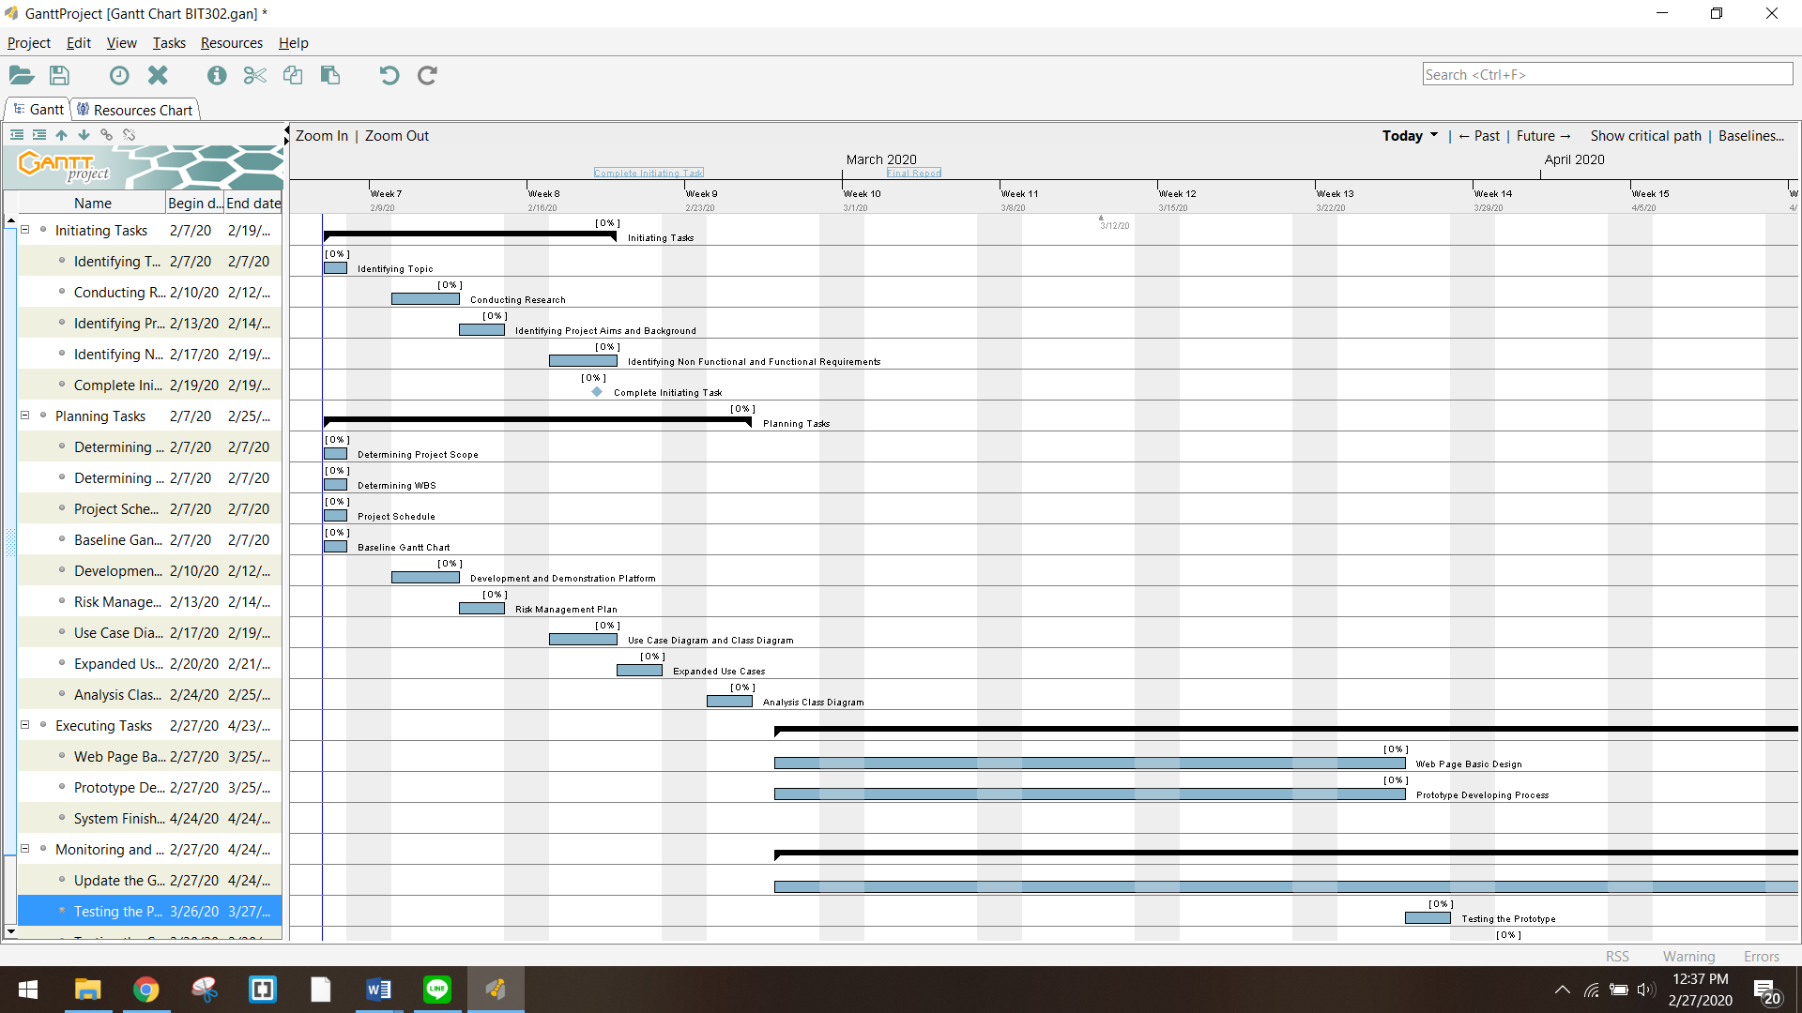

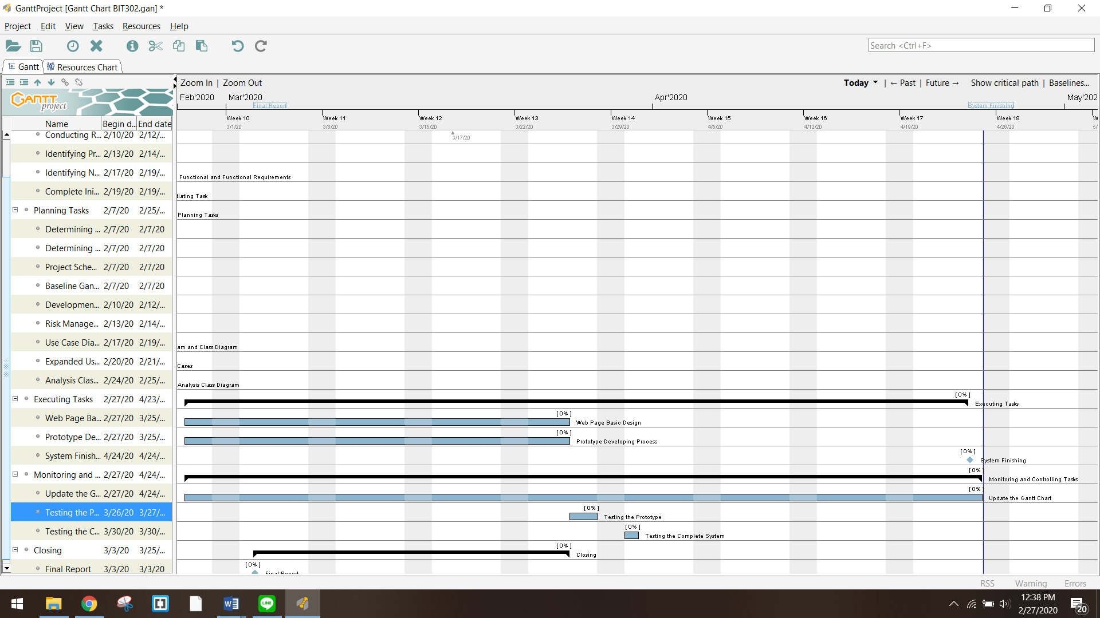

Development Platform

**Software/tools:**

1. **Microsoft Excel**

We will use Excel to store data and formula that we have collected before inputting them to database in MySQL.

1. **Microsoft Word**

We will use Word to produce documents and reports related to this project.

1. **Microsoft Power Point**

Power Point will be used to create presentation to show the design of our system and what went right or wrong during the development of the system.

1. **StarUML**

This is an open – source tool for Unified Modelling Language diagrams and modelling. We will use this tool to create use case diagram, class diagram and sequence diagram.

1. **MySQL**

We choose MySQL as our relational database management system because it is open – source and has many features to help us managing our database.

1. **Visual Studio Code**

Visual Studio Code will be used to write our html codes to design the interface for our web application.

1. **phpMyAdmin**

**We choose this tool because it is open – source and it can be connected to our database in MySQL. phpMyAdmin** provides a convenient graphical user interface to work with and it also has all common functions that we need to develop a MySQL-based application or website.

1. **Adobe Photoshop**

Photoshop is suitable to manipulate and edit images that will be used in our web application design.

1. **GanttProject**

GanttProject is an open – source project management software that we use to create Gantt chart which help us in scheduling works for this project.

**Hardware:**

1. **Laptop**

All the for developing this application will be done using laptops that run on Windows operating system.

Demonstration Platform

**Software:**

1. **Web browser – Google Chrome and Mozilla Firefox**

Because we are developing web based application, this application will be opened through a web browser. We choose Google Chrome and Mozilla Firefox to open our application because those are the most common browsers used nowadays. We also want to make sure our design and the data being displayed are consistent in both browsers.

**Hardware:**

1. **Laptop and PC**

Our application is intended to be opened through web browsers from laptop and personal computer.

Risk Management Plan

|  |  |  |  |  |  |  |  |  |  |  |  |
| --- | --- | --- | --- | --- | --- | --- | --- | --- | --- | --- | --- |
| Risk Management Plan for Development of  Web-based Information System for Micro Housing System in Kuala Lumpur | | | | | | | | | | | |
| Prepared by: Luh Wulandari Maharani & Rivaldo Bagus Soepardhy | | | | | | Date: Monday 30th February 2020 | | | | | |
| No | **Rank (1-5)** | **Risk** | **Description** | **Category** | **Root Cause** | **Triggers** | **Potential Responses** | **Risk Owner** | **Probability** | **Impact** | **Status** |
| R1 | 4 | Lack of understanding (or misunderstanding) of all the requirement in the project. | When requirements are not fully understood or when the deliverables are not according to the project scope, the system produced may not match what the users need. | Process Risk | Lack of research and understanding about the purpose / scope of the project. | Not enough time to carry out or poor brainstorming of the project’s scope. | Spare some times to conduct more research about similar application to learn about requirements that needed to be fulfil | Wulan | **High** | **Medium** | We thought to have a more commercialized information system (market place) while the project only need to have a sophisticated information system for the sake of management. It is resolved now. |
| R2 | 5 | The project working duration may be exceeded from the planned. | Team member may be overwhelmed with the project or busy agenda. | Process Risk | Each team member is busy with other activities. | Another project from other subject, Sudden personal agenda (Undeniable family occasion, etc.) | Do online discussion if it is not possible to physically conduct a meeting, tighten the work days to catching up missed days | All | **Medium** | **Medium** | Wulan needs to do ceremony due to religion obligation. Although so, we can still catchup through online platform and pushing work until now. |
| R3 | 4 | The system may possibly have some malfunctions. | The system might having bugs, crashes, or errors. | System Risk | Bad coding structure, logical error, software bugs. | Coding carelessly, not enough prototype / final testing. | Catching up by doing more intense testing, more thorough checking | Aldo | **Medium** | **High** | This issue has not happened yet. |
| R4 | 3 | Lack of communication that may lead to misunderstanding between team members. | Unclear task delegation, misunderstanding / miscommunication can cause different opinion or even conflict | People Risk | Each team member is busy with other activities. | Have different schedules that make it difficult to have same spare time to meet and communicate about the project. | Do online discussion if it is not possible to physically conduct a meeting, make a meeting schedule from the beginning of the project. | Wulan | **High** | **High** | It is common to have misunderstanding. In order to prevent this, we often communicate working in physical or online platform. |

***Probability and Impact Matrix***

|  |  |  |  |
| --- | --- | --- | --- |
| **High** |  | R1 | R4 |
| **Medium** |  | R2 | R3 |
| **Low** |  |  |  |
| ***Probability***  ***Impact*** | **Low** | **Medium** | **High** |

# References

Anderssen, E. (2018, July 19). *Seniors have too much house. Millennials have none. And a business model is born*. Retrieved from The Globe And Mail: https://www.theglobeandmail.com/canada/article-seniors-have-too-much-house-millennials-have-none-and-a-business/

Babulal, V., & Athirah, F. (2019, April 16). *B40 youths can soon rent DBKL micro-homes for RM100 a month*. Retrieved from NewStraitTimes: https://www.nst.com.my/news/nation/2019/04/480032/b40-youths-can-soon-rent-dbkl-micro-homes-rm100-month

Carney, J. (2018, April 20). *Six ways to solve Hong Kong housing problem – from water pipes to plastic bottles*. Retrieved from South China Morning Post: https://www.scmp.com/lifestyle/article/2142632/six-ways-solve-hong-kong-housing-problem-water-pipes-plastic-bottles

Nations, D. (2019, December 19). *What Exactly Is a Web Application?* Retrieved from Lifewire.com: https://www.lifewire.com/what-is-a-web-application-3486637

Regan, R. (2018, May 30). *Stanford Social Innovation Review*. Retrieved from A New Approach to Solving the US Housing Crisis: https://ssir.org/articles/entry/a_new_approach_to_solving_the_us_housing_crisis#

Valacich, J., & Schneider, C. (2010). *Managing in the Digital World: Fourth Edition.* Prentice Hall.